Marin Sanitary Service
L U N C H E O N I N V I T A T I O N
February 16, 2017
12 - 2 p.m.

NO CHARGE for luncheon
RSVP No later than February 3, 2017
Sponsors: San Anselmo Chambers of Commerce
Register for Event: (415) 454-2510, San Anselmo or sananselmochamber.org | Register for Events
PRESENTATION TOPIC
Ross Valley Sanitary District
SAN ANSELMO AVENUE
Large Diameter Gravity Sewer Rehabilitation Project II-2
The Ross Valley Sanitary District (RVSD) provides wastewater utility service to businesses and residents in Central Marin County, including the Town of San Anselmo. Much of the District’s aging infrastructure is between 50 and 75 years old and in need of rehabilitation. In order to improve the safety and reliability of the system and to reduce the potential for sanitary sewer overflows that could pollute local waterways, the RVSD is implementing an aggressive Capital Improvement Program. An important component is the rehabilitation of approximately 3,033 Linear Feet of sanitary sewer pipe in Downtown San Anselmo using Cured-In-Place-Pipe lining rehabilitation methods. The RVSD is working closely with Town Officials to mitigate impacts to the business community as much as possible. This includes pre-approved traffic control measures, scheduling work so that most businesses will not be affected during normal hours of operation, less intrusive rehabilitation methods and the use of less odiferous pipe lining materials. Construction is scheduled to be completed in segments over about a three-month period in the Spring of 2017.

Presenters:
Jim Smith, Ross Valley Sanitary District Andy Deal, Covello Group
Colin Dudley, Brown and Caldwell Andrew Clough, AB Clough Consulting

Luncheon Generously Hosted by Marin Sanitary Service
535 Jacoby Street, San Rafael| UPSTAIRS
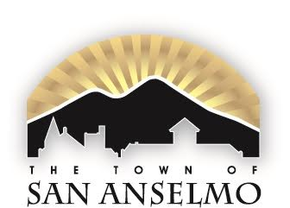
MARIN SANITARY SERVICE

